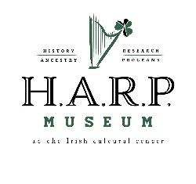
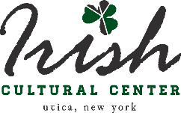
H.A.R.P. (“History, Ancestry, Research and Programs”) Museum
at the Irish Cultural Center of the Mohawk Valley
“Growing Our Future on the Roots of Our Past”

Object Donation Form Donation number: (office use) __________________
I am/We are the owner/owners of the object/s described in the schedule below and I/We hereby donate such object/s to the H.A.R.P. Museum at the Irish Cultural and Historical Society of the Mohawk Valley (ICCMV).
The object/s donated is/are not encumbered in any way whatsoever.
I/We acknowledge that the donation as such will result in the H.A.R.P. Museum becoming the owner at law of the said object/s, with all rights and powers to do with the said object/s as it sees fit. This may include disposal, which may or may not include efforts to return the object/s to the donor or the donor’s heirs.
I/We consent to the H.A.R.P. Museum retaining the personal information disclosed below.
I/We give permission to the above-named museum to use the information I/We have provided about the history of the object/s for future museum purposes, including research, public research access, displays and publications.
Restrictions on public access to information provided:
_______________________________________________________________________________________
________________________________________________________________________________________
Contact details of donor/s: (include name(s), address, email and telephone number/s):
________________________________________________________________________________
________________________________________________________________________________________
What artifacts or library materials are you offering to donate to the H.A.R.P. Museum? Please describe the artifact as specifically as possible. Include measurements, weight, color, etc:
________________________________________________________________________________________
________________________________________________________________________________________
________________________________________________________________________________________
What is the history significance of your materials and how do they relate to Irish culture and/or history? (Date made, previous owners, usage history, etc.):
________________________________________________________________________________________
________________________________________________________________________________________
________________________________________________________________________________________
Please attach at least two color photos of the artifact.
Signature/s: __________________________________________ Date: ______________________

