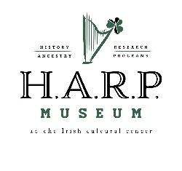
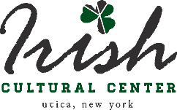
H.A.R.P. (“History, Ancestry, Research and Programs”) Museum
at the Irish Cultural Center of the Mohawk Valley
“Growing Our Future on the Roots of Our Past”

DONATION POLICY
Donation Offers
The H.A.R.P. Museum at the Irish Cultural Center of the Mohawk Valley (ICCMV) collects artifacts, papers, images and publications that support its mission of displaying and preserving Irish culture in the Mohawk Valley. We use these items to tell the story of our region’s people, places, activity and events.
The following criteria guide our collecting:
- Offered items must be relevant to our mission of preserving Irish heritage, history and culture.
- The museum must be able to provide adequate care for an item or collection
- We do not purchase items for the collection, except in extremely rare circumstances
The H.A.R.P. Museum does NOT accept:
- Duplicate items, such as the third, fourth or fifth copy of an Irish history book
- Conditional donation offers; e.g., donations offered based on getting assurance that an artifact will be permanently or prominently displayed
- Materials that may constitute a threat to our people, our building or our collections, such as chemicals, explosives or those with active mold/pest infestations
Please note:
- Only the H.A.R.P. staff/museum committee can accept or decline donation offers. Trustees and volunteers may engage in discussions with prospective donors, but do not have the authority to accept items for the collection
- The donor transfers all rights of ownership, including copyright, to the H.A.R.P. Museum at the Irish Cultural Center of the Mohawk Valley, once a donation is accepted. There is a separate policy for artifacts, etc., loaned to the museum.
If you have an item or collection that you would like to donate, please send an email to iccmv.museum@gmail.com with “COLLECTIONS” as its subject. Under no circumstances shall a collection or item be dropped off at the ICCMV without having made arrangements with the museum. The ICCMV assumes no responsibility for the safe transfer of such items.
Thank you for being a part of our history!

623 COLUMBIA ST., UTICA NY, 13502, Ph: (315) 733-ICCU (4228)
Email: ICCMV.Museum@gmail.com

