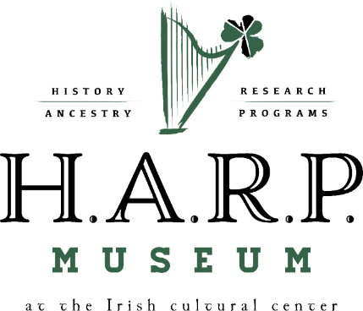
The H.A.R.P. (“History, Ancestry, Research and Programs”) Museum at the Irish Cultural Center of the Mohawk Valley is the first Irish museum in Utica’s long and storied history. It was established to capture and pass on the rich history of the local Irish community, and the many cultural contributions and influences they have endowed to us all.

We are a 100% volunteer organization, dependent on the generosity of individuals and corporate sponsors. As such, we have established a “Friends of the H.A.R.P. Museum” membership plan, described below. Your tax-deductible membership fee will help support our ongoing efforts to promote and preserve the rich heritage of local, regional and national Irish culture for future generations.
BENEFITS INCLUDE:

- Free admission to the H.A.R.P. Museum
- Quarterly Newsletter
- Advanced notification of upcoming events
- Discounted admission to most concerts/events
- Free unlimited access to Ancestry.com
- Free access to research/reference library
- 10% discount on all H.A.R.P. Museum merchandise
- Access to video archives of past performances
- $5 “Members Only’ coupon for the Five Points Pub
- The rewarding opportunity to support the preservation of Irish history and culture
JOIN AT ONE OF THE FOLLOWING LEVELS:
___ $20 | Senior (>62), Student, Military
___ $35 | Individual
___ $50 | Family (benefits for two adults and all children)
___ $75 | Supporter (individual membership plus two guest cards)
___ $125 | Patron (two individual memberships plus two guest cards)
___ $250 | Corporate (two individual memberships plus four guest cards, concert “meet and greets,” advertisement in our newsletter)

Name:
Address:

Phone:
E-Mail:
Additional donation __________ (Contributions in addition to dues are always welcome. The Irish Cultural Center of the Mohawk Valley is a qualified 501(c)(3). All contributions are 100% tax deductible under IRS regulations).

I would like my donation to go toward:
___ Programs and Presentations
___ Museum operations
___ Other (specify)

Are you interested in Volunteering? If so, may we contact you by phone? _____ Email?____

Please make your check payable to “Irish Cultural Center” (put “membership” on the memo line) and mail to:
Membership Drive
Irish Cultural Center of the Mohawk Valley
623 Columbia St.
Utica NY 13502

THANK YOU FOR SUPPORTING THE PRESERVATION OF IRISH HISTORY AND CULTURE!

